RESUME

19/J,206,SHANGHARSH NAGAR

CHANDIVALI EAST ,MUMBAI
MOBILE NO-9819614984,
PASSPORT NO: G6520639

BISWA RANJAN DAS

E-mail:-das75d@gmail.com
__________________________________________________________________________________________

Objective:
Looking for the greatest opportunity to work as a GIS analyst for a reputed company.
. Skills:
- Having 2.5 year experience with using ArcGIS. AUTO CARD
- Excellent knowledge of databases such as Access,
- Excellent communication and writing skills.
- Excellent fundamental knowledge and skill in the operation of GIS equipment that includes computer hardware, printer setup,
- Familiar with GIS applications in public policy and planning.
- Able to coordinate multiple projects simultaneously.
- Responsible for other duties as assigned.
- Computer Skills: Proficient with
- Good in MS Access, MS PowerPoint
- Good knowledge of Arc-GIS, Auto-Cad software'
- GIS and Image Processing
- Arc GIS 9.2, Arc VIEW 3.2a,
- Ms Office, Adobe Photoshop 7.0
- DOS, Microsoft XP, Windows Vista/7
Work Experience:
GENESYS INTERNATIONAL CORPORATIONAL LTD,MUMBAI
GIS Technician/EXECUTIVE
- Stored and updated GIS related data on roads, drainage, Building, and water supply etc
- Operated new equipment with the help of computer software
- Observed aerial images to identify and understand important business, topographical data
- Solved software users inquiries and problem with proper solution
- Handled GIS related software to manipulate spatial and quality data
- Collected and organized databases of service areas of .
- Responsible for creating maps of service areas.
- Done other duties as assigned.
SUMMARY OF QUALIFICATIONS
- Matriculation from Board of Secondary Education Orissa, in the year of 1990.
- Inter from Council of Orissa, COMMERCE in the year of 1992.
- B. COM. From Utkal University Orissa, in the year of 1995.
- M B A (MARKETING) from AWDI, AICTE DELHI in the year of 1997.
- P.G.D.C.A From SAHA EDUCATION SOCIETY.CUTTACK in the year of 1998.

Project Undertaken
Company Name : Dissertation on Media Effectiveness for HMT Watches.
Purpose : To measure the advertisement effectiveness and the brand awareness of HMT Watches.
Duration : Eight week
Joining Time Required : Immediate

Self Assessment Information

Father’s Name : Dr. Bijay Kumar DAS
Date of Birth : 18th May 1975.
Nationality : Indian.
Religion : Hindu
Sex : Male
Marital Status : Married
Language Known : Oriya, Hindi & English
Expected Salary : Negotiable
Hobbies : Making new friends, Reading news papers, Listening Music,
Watching T.V
Declaration
I certify that the above information is correct and true to the best of my knowledge and belief. In the event of any information being found false or incorrect, action can be taken against me. Further declare that I have never been arrested/prosecuted and convicted by a Criminal Court or involved any other case registered by the Police.

Date: 21 /02/ 2013
Place: MUMBAI 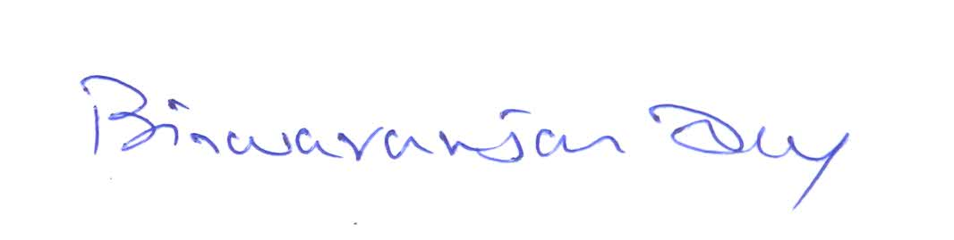 . BISWA RANJAN DAS

